MLDL
PRACTICAL 6
Name: Payal Dara
Class: D15C
Roll no: 56
Batch: C

AIM:-
Apply K-Means and Hierarchical Clustering on sample datasets
K-Means Clustering

1. Dataset Source
Dataset Name: Mall Customer Segmentation Dataset
Source: Kaggle Dataset Repository
Dataset Link:
https://www.kaggle.com/datasets/vjchoudhary7/customer-segmentation-tutorial-in-python
Data Collected By: Shopping Mall Management
Data Collection Method: Customer purchase and demographic records collected by the mall.

2. Dataset Description
The Mall Customer Segmentation dataset contains information about customers visiting a shopping mall. The purpose of the dataset is to analyze customer behavior and group customers into different segments based on their spending patterns.
Clustering algorithms like K-Means are used to identify groups of customers with similar characteristics.

Dataset Size
Number of Instances: 200 customers
Number of Features: 5 features
Target Variable: None (Unsupervised Learning)

Dataset Characteristics
Real-world marketing dataset
Used for customer segmentation analysis
Contains both categorical and numerical attributes
Suitable for clustering algorithms

Feature Description

Feature Name | Description
CustomerID | Unique identifier for each customer
Gender | Gender of customer
Age | Age of customer
Annual Income (k$) | Annual income in thousand dollars
Spending Score (1–100) | Score assigned by the mall based on customer spending behavior

3. Mathematical Formulation of K-Means Clustering
K-Means is an unsupervised learning algorithm used to partition data into K clusters based on feature similarity.
The algorithm aims to minimize the Within Cluster Sum of Squares (WCSS).
Objective Function:
J=∑i=1k∑x∈Ci∣∣x−μi∣∣2J=i=1∑k​x∈Ci​∑​∣∣x−μi​∣∣2
Where:
kk = number of clusters
CiCi​ = cluster ii
xx = data point
μiμi​ = centroid of cluster ii

Algorithm Steps
- Choose number of clusters K
- Randomly initialize K centroids
- Assign each data point to the nearest centroid
- Recalculate centroids of clusters
- Repeat steps 3–4 until centroids stop changing

4. Algorithm Limitations (K-Means)
Requires predefined number of clusters K
Sensitive to initial centroid selection
Does not perform well with non-spherical clusters
Sensitive to outliers
Works best with numerical data only
May converge to local optimum

5. Methodology / Workflow
Steps performed in the experiment:
Load the mall customer dataset
Select relevant features (Income and Spending Score)
Handle missing values if present
Perform feature scaling
Use Elbow Method to determine optimal number of clusters
Apply K-Means clustering algorithm
Assign cluster labels to each customer
Visualize clusters using scatter plots
Analyze customer segments

Workflow Diagram (Textual)
Dataset
↓
Data Preprocessing
↓
Feature Selection
↓
Feature Scaling
↓
Optimal Cluster Selection (Elbow Method)
↓
K-Means Model Training
↓
Cluster Assignment
↓
Cluster Visualization and Analysis

6. Performance Analysis
Since clustering is an unsupervised learning technique, traditional accuracy metrics are not used.
Instead, clustering quality is evaluated using:

Evaluation Metrics
Within Cluster Sum of Squares (WCSS)
Silhouette Score
Cluster Visualization

Interpretation
Lower WCSS indicates tighter clusters
Higher Silhouette Score indicates well-separated clusters
Visualization helps identify meaningful customer segments

7. Hyperparameter Tuning (K-Means)
Key hyperparameters:

Parameter | Description
n_clusters | Number of clusters
init | Method of centroid initialization
max_iter | Maximum number of iterations
n_init | Number of times algorithm runs with different centroids
Output:-
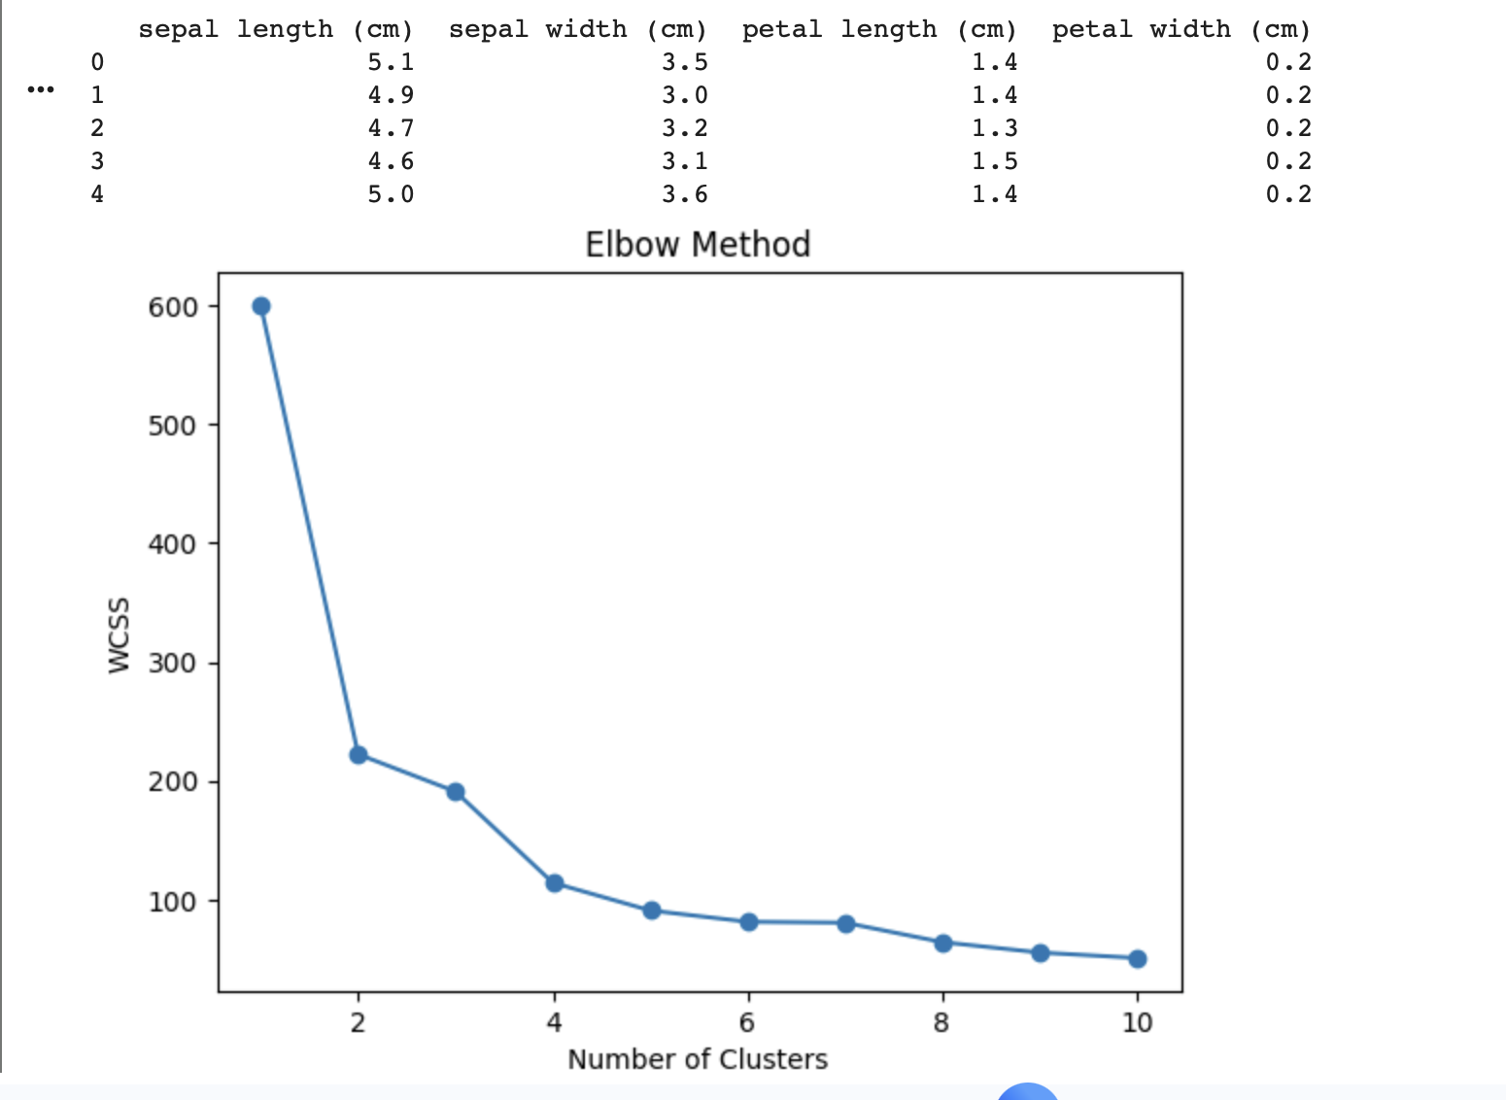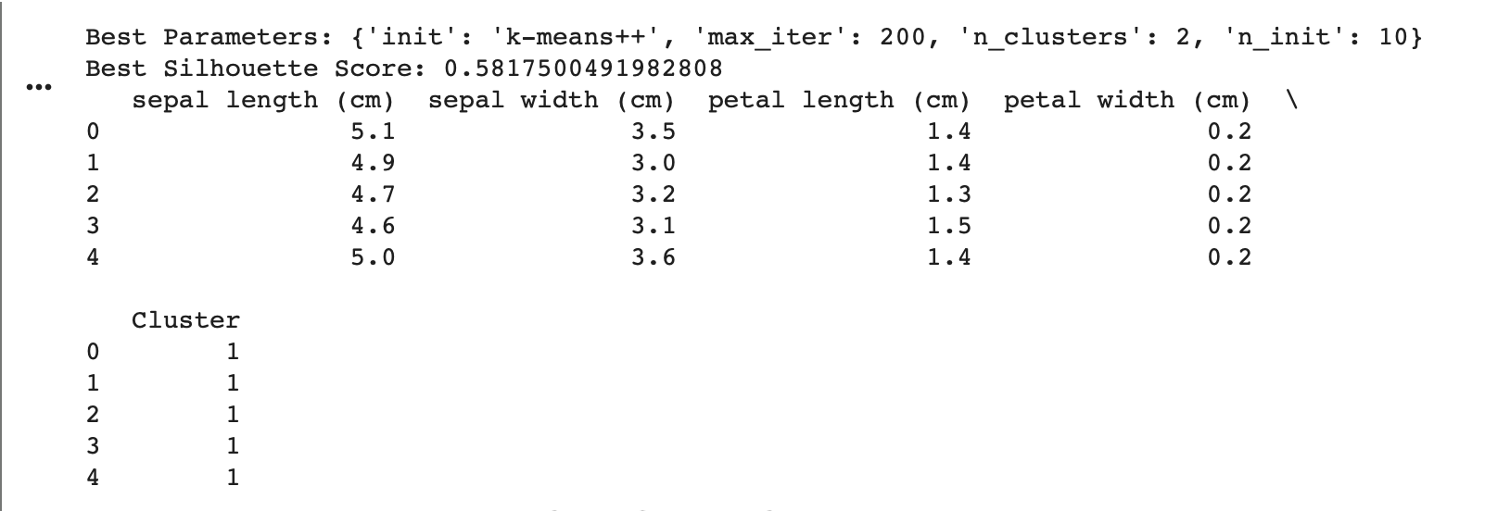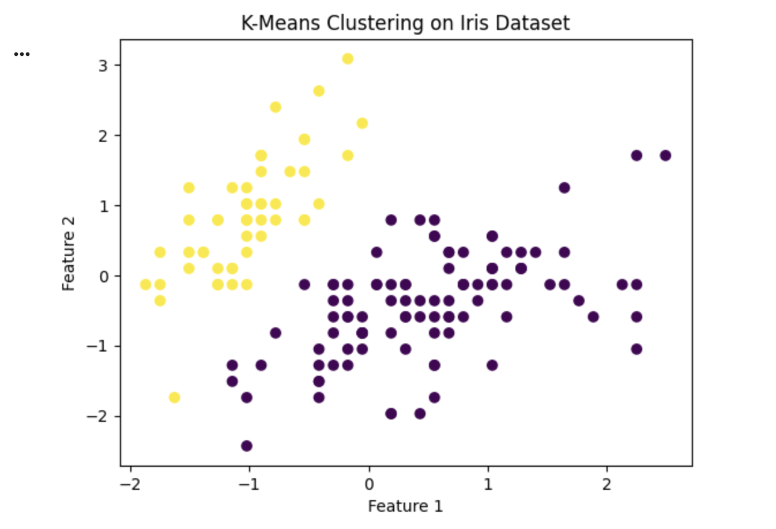

Hierarchical Clustering

1. Dataset Source
Dataset Name: Iris Dataset
Source: UCI Machine Learning Repository
Dataset Link:
https://archive.ics.uci.edu/ml/datasets/iris

2. Dataset Description
The Iris dataset is a classic dataset used in machine learning for classification and clustering problems. It contains measurements of iris flowers belonging to three species.
Hierarchical clustering groups similar flower samples based on feature similarity.

Dataset Size
Number of Instances: 150 samples
Number of Features: 4 features

Feature Description

Feature | Description
Sepal length | Length of sepal
Sepal width | Width of sepal
Petal length | Length of petal
Petal width | Width of petal

3. Mathematical Formulation of Hierarchical Clustering
Hierarchical clustering builds a tree-like structure called a dendrogram to represent nested clusters.
Distance between clusters is calculated using distance metrics such as Euclidean distance.
Distance formula:
d(x,y)=∑i=1n(xi−yi)2d(x,y)=i=1∑n​(xi​−yi​)2​
Where:
xx and yy are data points.

Types of Hierarchical Clustering
Agglomerative (Bottom-up approach)
Divisive (Top-down approach)

Linkage Methods
Single Linkage
Complete Linkage
Average Linkage
Ward’s Method

4. Algorithm Limitations (Hierarchical Clustering)
Computationally expensive for large datasets
Once clusters are merged, they cannot be split
Sensitive to noise and outliers
Requires careful selection of distance metric

5. Methodology / Workflow
Load the Iris dataset
Perform data preprocessing
Standardize the dataset
Compute distance matrix
Apply Agglomerative Hierarchical Clustering
Generate dendrogram visualization
Select optimal number of clusters
Analyze cluster structure

Workflow Diagram (Textual)
Dataset
↓
Data Preprocessing
↓
Distance Matrix Calculation
↓
Hierarchical Clustering Algorithm
↓
Dendrogram Generation
↓
Cluster Selection
↓
Cluster Analysis

6. Performance Analysis
Clustering performance is evaluated using:
Silhouette Score
Dendrogram visualization
Cluster compactness

Interpretation
Clear separation in dendrogram indicates well-formed clusters
Higher silhouette score means better clustering quality
Clusters correspond closely to natural flower species groups

7. Hyperparameter Tuning (Hierarchical Clustering)
Important parameters:

Parameter | Description
n_clusters | Number of clusters
linkage | Method used to merge clusters
affinity | Distance metric used
Output ➖
